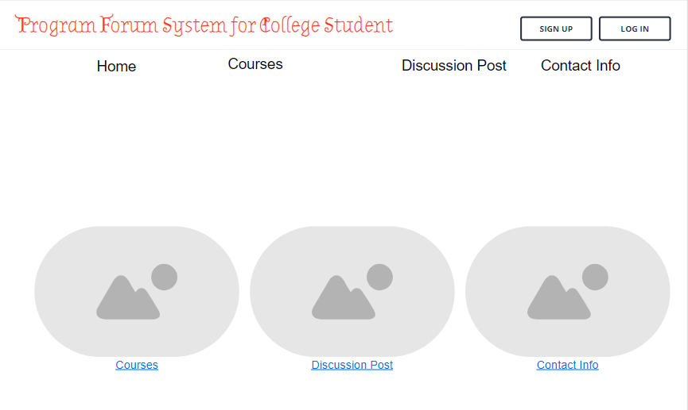**Task 4 – Protrotype of User Interface**

**Home Page 1.1**

Student can straight go to the pages by clicking the link through home page.

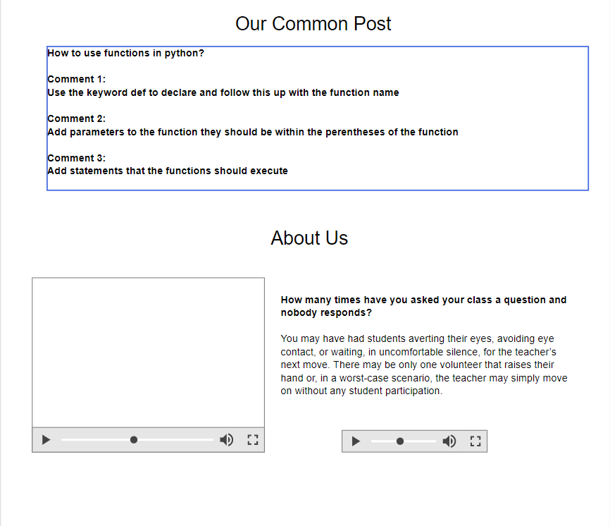

**Home Page 1.2**

Our System will auto filter out the common post and show on the home page sometimes if lucky student will no need find the question or post the question they straight get the answer through the home page.

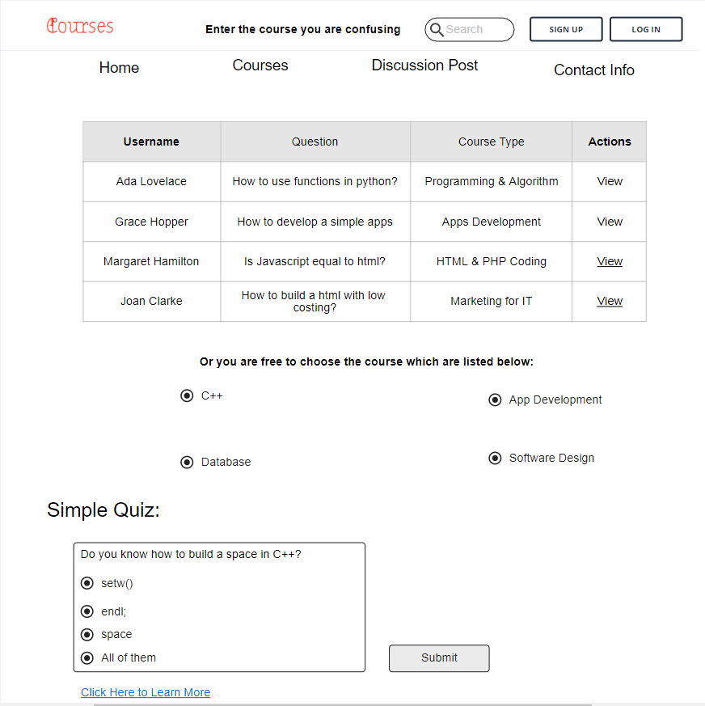

**Course Page 2.1**

By using this page, student can straight filter out the question. For example, if the student questions is about Software Design student can straight select the course software design and it will open a new page and show all the question which have posted and all the common about the courses.

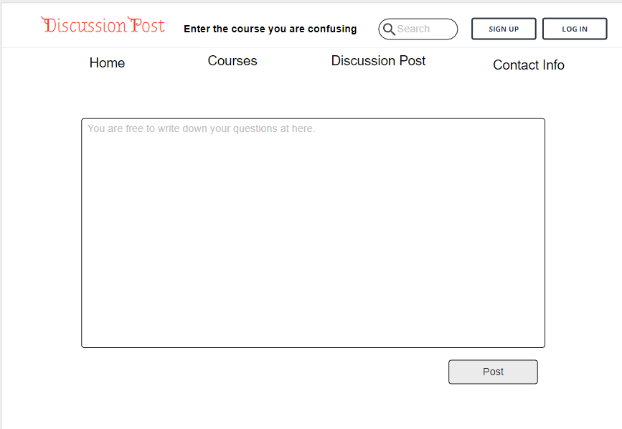

**Discussion Post Page 3.1**

Student can post their question by using this pages. All the answer or the common by other student will send to their email.

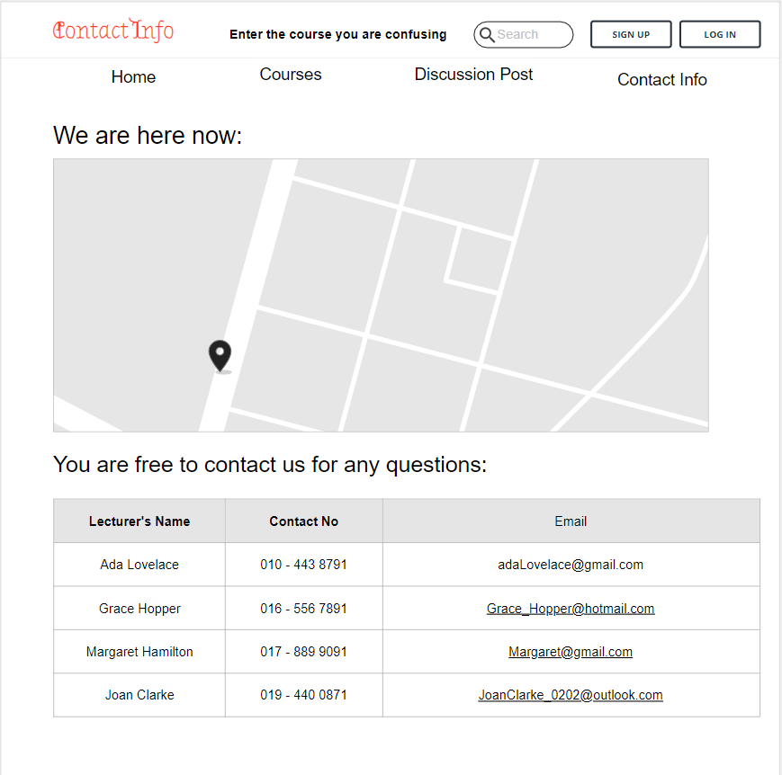

**Contact Info Page 3.1**

For some special to our student who have subscribe our software can straight contact our personal lecture through email or phone no.